Installation of Performance Monitor in Windows

1. Download and unpack

<https://ci.appveyor.com/api/buildjobs/ya2o02uo3hpt8hil/artifacts/pcm-all.zip>

1. Download the free RealTemp utility package from <http://www.techpowerup.com/realtemp/> or any other free utility that uses the open-source WinRing0 driver
2. Copy WinRing0.dll, WinRing0.sys, WinRing0x64.dll, WinRing0x64.sys files from there into the PCM.exe binary location, into the PCM-Service.exe location and into c:\windows\system32
3. Run the PCM.exe tool from command line (admin)
4. Execute '"PCM-Service.exe" -Install' from this directory (admin)
5. Execute 'net start pcmservice' (admin)
6. Start Performance Monitor in Windows (Note: Need to find “Performance Monitor” in your own language if your OS is not in English )  
   A screenshot of a computer

   Description automatically generated
7. Click “+” and select PCM Socket Counter  
   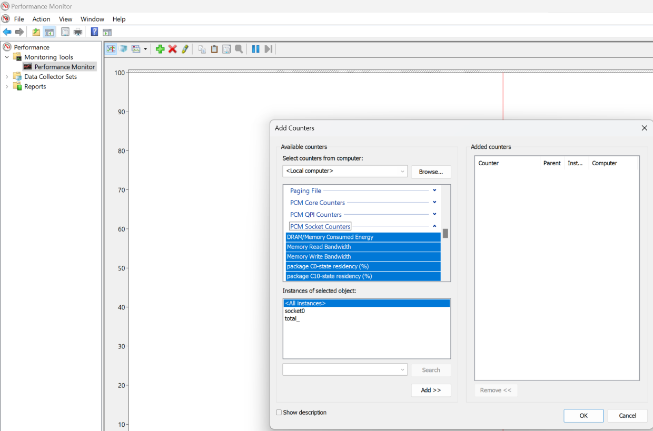;p
8. Select Package/Socket Consumed Energy and total and it to “Added counter”  
   A screenshot of a computer

   Description automatically generated
9. You can monitor power consumption now

